**III. BUILD AND EVOLVE AGILE TEAMS**

Introduction

Lesson Introduction

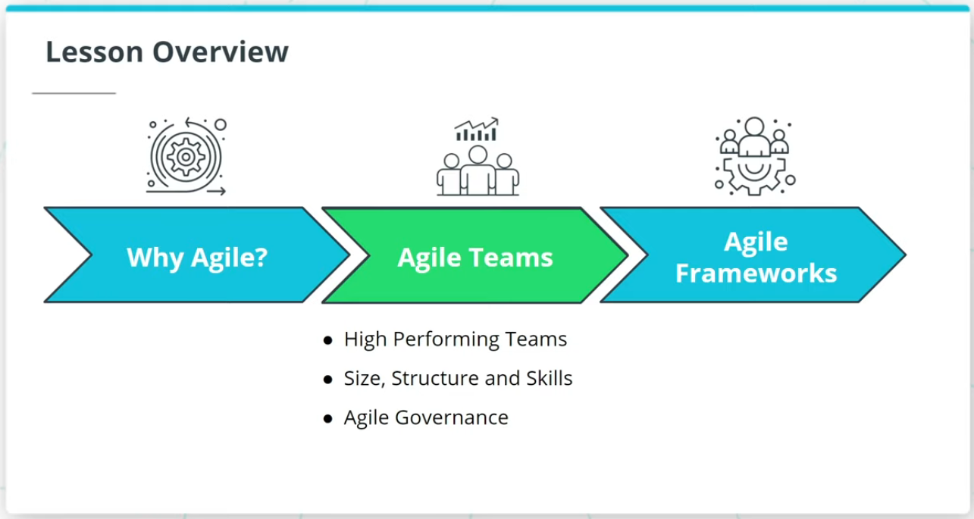

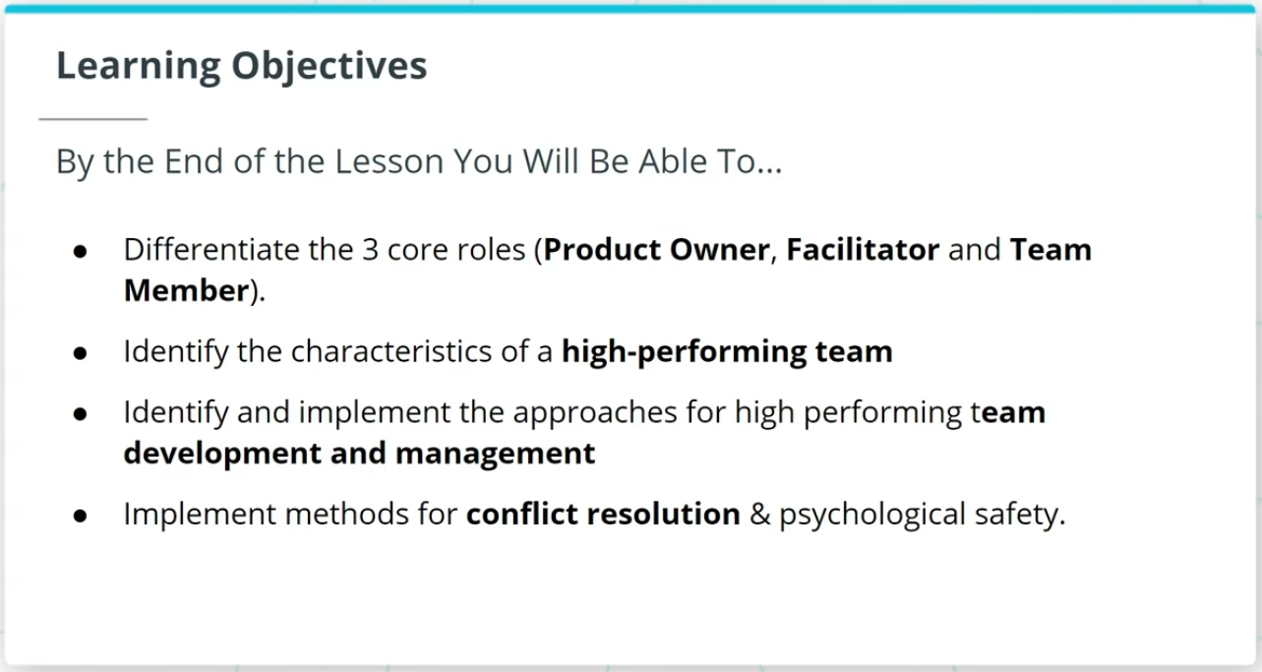

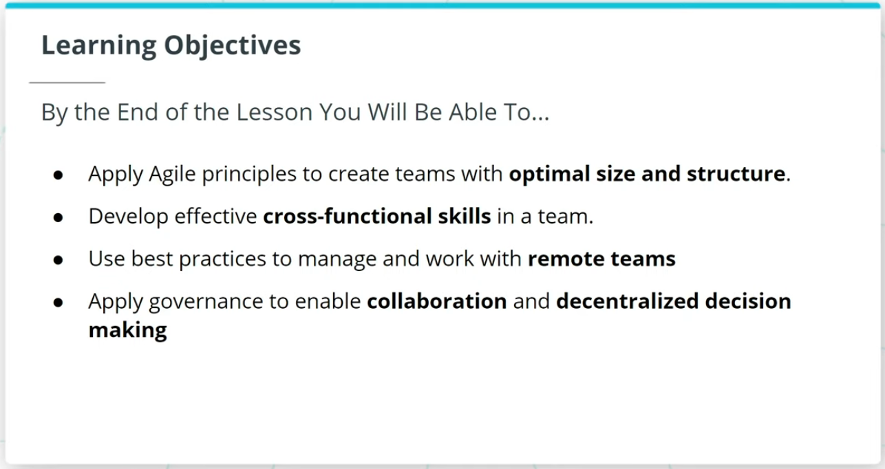

Welcome to a lesson on Agile Teams. In the last lesson, we talked about the importance of Agile.

This lesson will cover the following key topics:

### **High Performing Agile Teams**

* How Agile Teams are the vehicle that delivers valuable work tied to business-driven product features and functionality.
* Characteristics of a high-performing Agile Team.
* How to sustain High Performing Teams.

### **Size, Structure, and Skills of an Agile Team**

* The 3 core roles in Agile.
* An Agile Team’s optimal size, structure, and cross-functional skills.

### **Agile Governance**

* Agile Governance and how Agile governance leverages The Agile Manifesto’s guidelines to balance assurance with adaptability.

### **By the End of the Lesson, You Will Be Able To...**

* Differentiate the 3 core roles (Product Owner, Facilitator, and Team Member)
* Identify the characteristics of a high-performing team
* Identify and implement the approaches for high performing team development and management
* Implement methods for conflict resolution & psychological safety
* Apply Agile principles to create teams with optimal size and structure
* Develop effective cross-functional skills in a team
* Use best practices to manage and work with remote teams
* Apply governance to enable collaboration and decentralized decision making

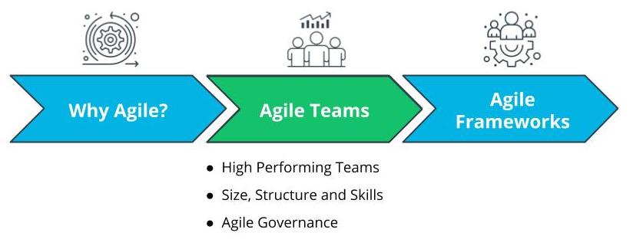

Lesson Overview - Agile Teams

# Why Agile Teams?

## Why Do Agile Teams Matter?



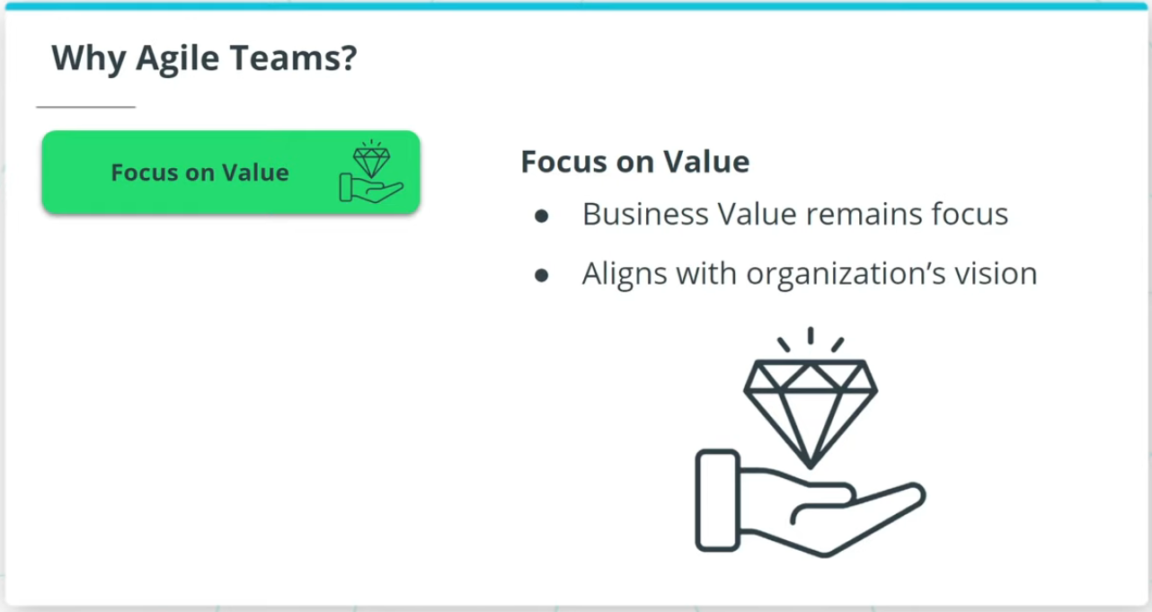

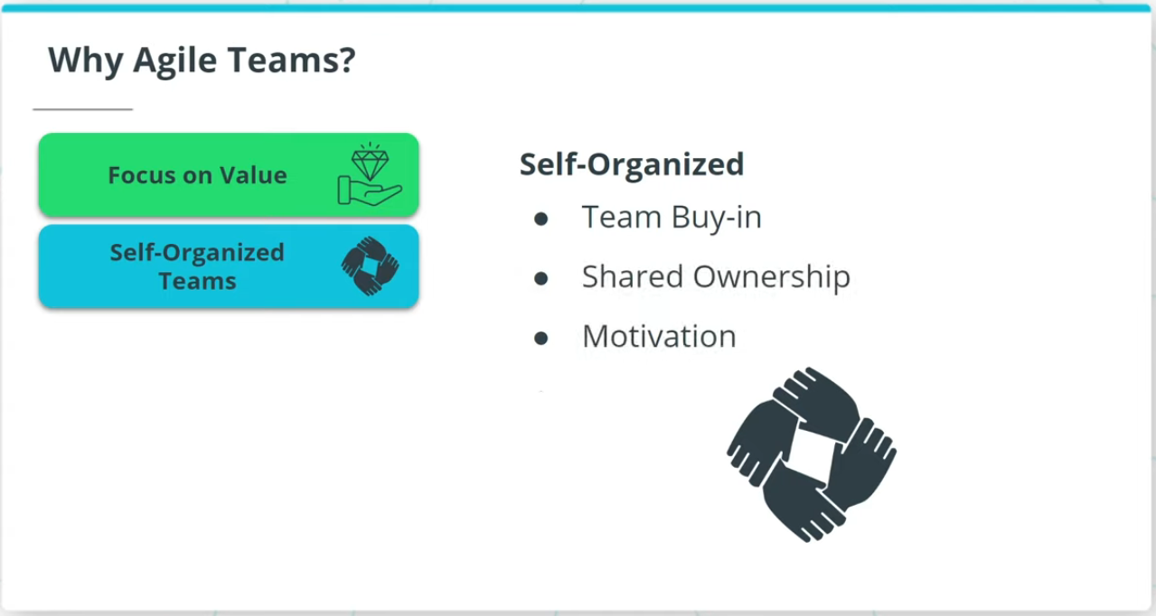

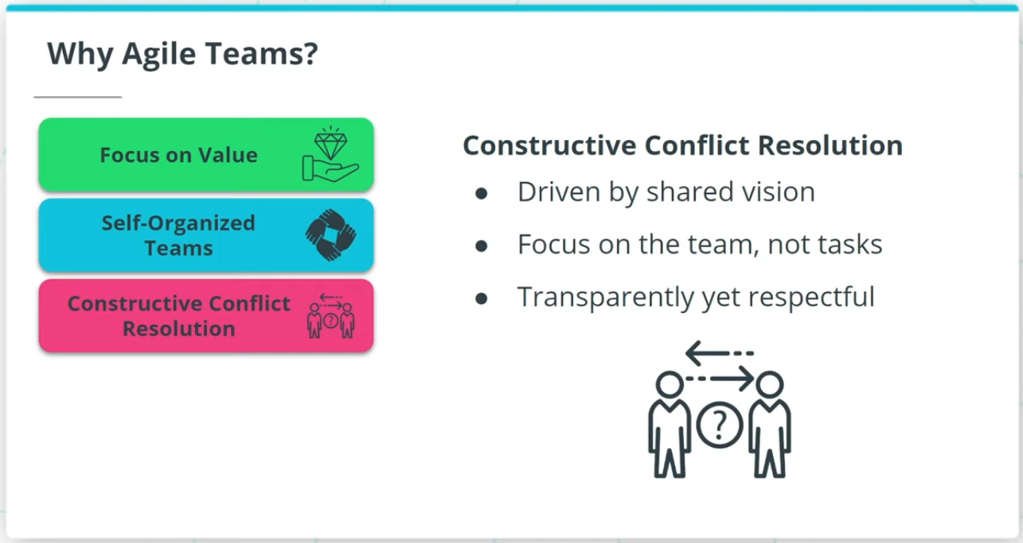

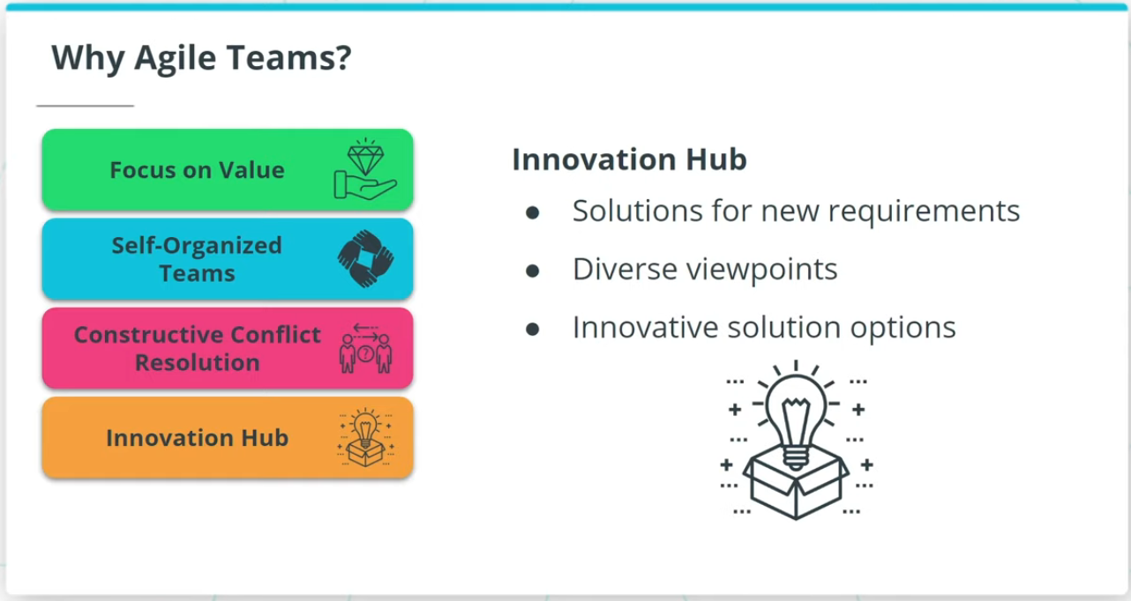

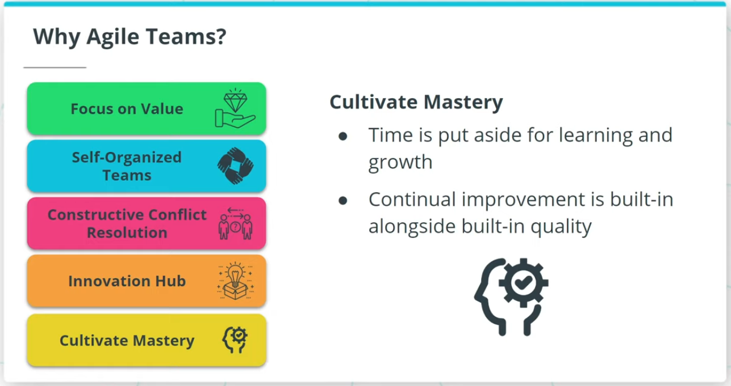

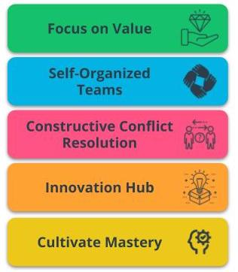

Benefits of Agile Teams

### **Agile Teams are a critical vehicle to deliver valuable results because of the following:**

* **Focus on Value** - Agile is driven by the goal of delivering maximum business value that is aligned with the organization’s vision.
* **Self-Organized Teams** - Agile Teams have the autonomy to make some de-centralized decisions, which allows for shared ownership of the work.
* **Constructive Conflict Resolution** - Conflicts in Agile Teams are constructively resolved because the team is driven by a shared vision.
* **Innovation Hub** - Agile Teams, with diverse and cross-functional skill sets, are an innovation hub that spurs solutions.
* **Cultivate Mastery** - Time is put aside in Agile Teams for learning and growth. This allows Agile Team members to sharpen their skills.

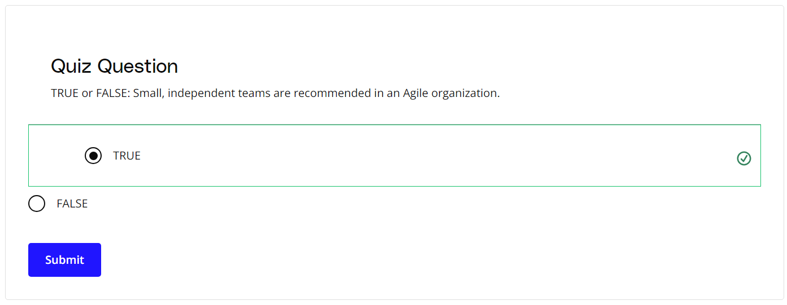

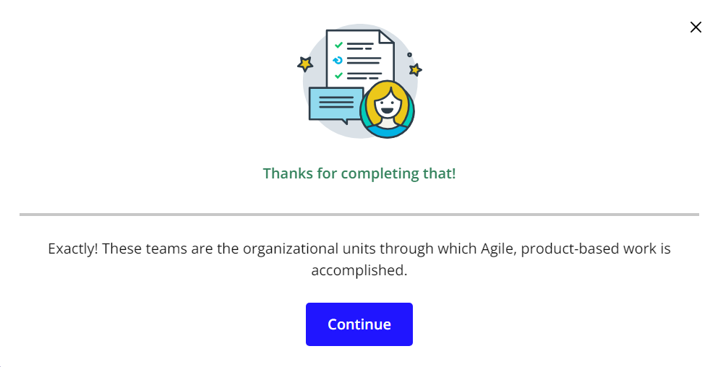

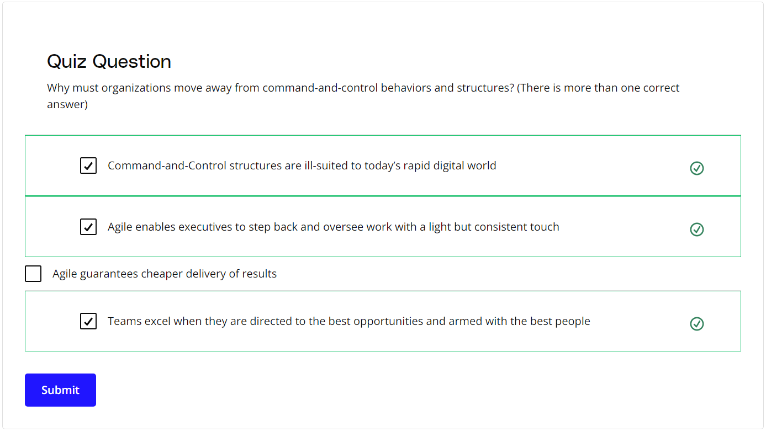

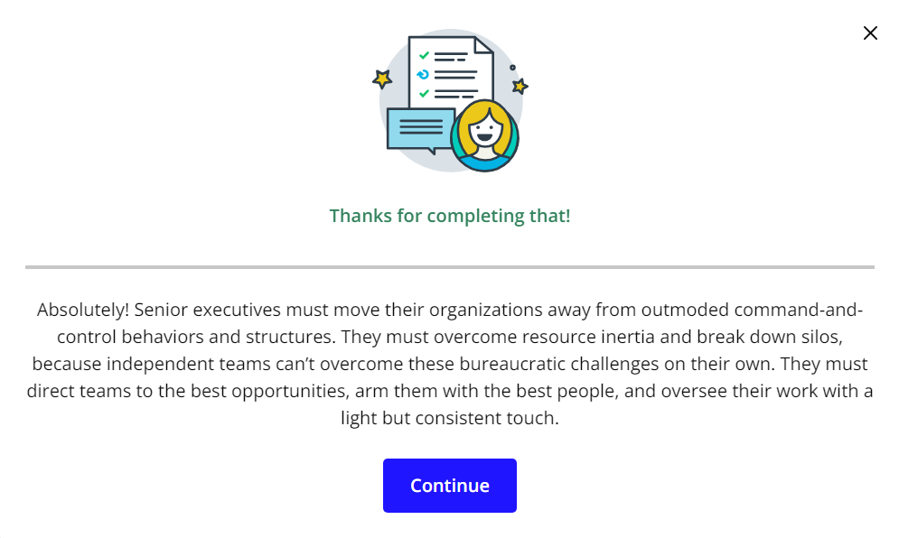

### **New Terms**

* **Innovation Hub**: Proactively working towards continual improvement with no compromise on technical excellence and quality
* **Self-Organized**: The team determines tasks and makes technical decisions about the work to be done after being given priorities by the Product Owner

### **Additional Resources**

* [**5 Ways to Organize Agile Teams**](https://www.scrumalliance.org/agile-resources/resources-for-your-agile-life/agile-advanced/may-2016/select-repost-5-ways-to-organize-agile-teams): This blog post from the Scrum Alliance describes five techniques to organize Agile teams successfully.